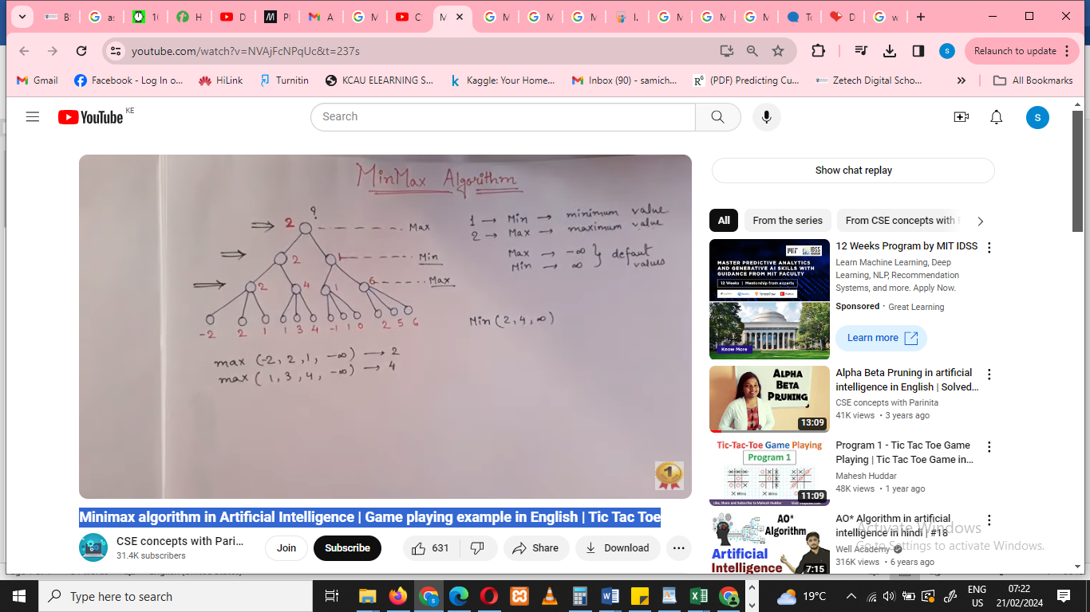

Assign Max value to 1 player and Min value to another player

In the field of artificial intelligence, infinity is used to describe the potential of an AI agent to improve its performance indefinitely.

Drawback of mini max is time complexity.to improve performance alpha beta algorithm is used

**Alpha beta pruning** to remove redundant paths (un wanted paths to improve efficiency) by killing the paths

